- List 3 real-world devices in your home or college that use SMPS (Switched Mode Power Supply) and 2 devices that use UPS (Uninterruptible Power Supply), explaining in one line why each device needs that type of power supply.
Devices using SMPS (Switched Mode Power Supply)
- Desktop Computer – Needs SMPS to efficiently convert AC mains into regulated DC voltages for CPU, GPU, and peripherals.
- Laptop Charger – Uses SMPS to provide compact, lightweight, and efficient DC output for battery charging.
- LED Television – Requires SMPS to step down and regulate voltage for display circuits while minimizing power loss.
Devices using UPS (Uninterruptible Power Supply)
- Computer Lab Servers – Depend on UPS to ensure continuous operation during power outages, preventing data loss.
- Wi-Fi Router – Uses UPS to maintain uninterrupted internet connectivity during short power failures.

- Draw and label a diagram showing the main internal components of a typical SMPS unit found in a desktop PC, including AC input, rectifier, transformer, and DC output sections.<br><br><em><strong>Hint:</strong> You can hand-draw and upload a photo, or use any free diagram tool like draw.io.</em>
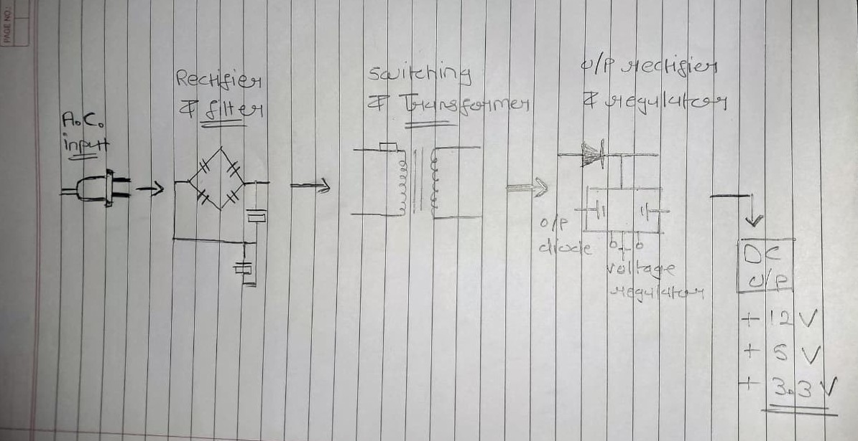

- Take photos or find clear images online of the following power connectors: ATX 24-pin motherboard connector, SATA power connector, Molex connector, and PCIe 6/8-pin connector. For each, write its name, the devices it powers, and one safety tip for connecting/disconnecting it.

- ATX 24-PIN :
- 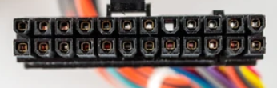 Devices Powered: Entire motherboard (chipset, RAM, PCIe slots, onboard devices).
- Safety Tip: Always press the latch before pulling—forcing it out can bend pins or crack the socket.
- SATA power connector :
- 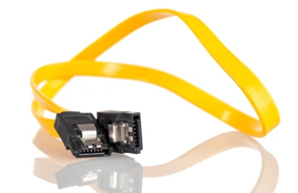 Devices Powered: Hard drives (HDD), solid-state drives (SSD), optical drives.
- Safety Tip: Avoid angled stress on the connector—its slim plastic housing is fragile and can snap easily.
- MOLEX Connector :
- 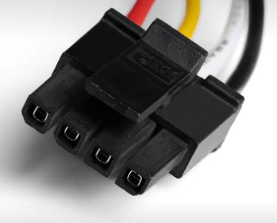 Devices Powered: Legacy HDDs, optical drives, case fans, some peripherals.
- Safety Tip: Do not wiggle excessively when disconnecting—the pins can loosen inside the housing, causing poor contact or sparks.
- PCIE 6/8PIN :
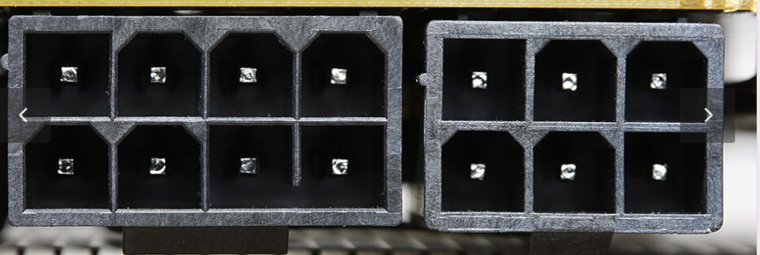 Devices Powered: Graphics cards (GPUs), sometimes high-performance PCIe expansion cards.
Safety Tip: Ensure full insertion until the latch clicks—partial seating can cause overheating and GPU instability.

4. to connect the SMPS to the motherboard, graphics card, and storage devices Imagine you are setting up a new gaming PC. List the steps you would follow, mentioning which specific cables and connectors are used for each.
01
Connect the ATX 24-Pin to Motherboard
- Align the 24-pin cable from the SMPS with the socket.
- Press firmly until the latch clicks into place.
02
Attach the 8-Pin CPU Power Connector
Provides dedicated power to the CPU for stable performance.
- Connect the matching cable from the SMPS.
- Ensure the latch locks securely.
03
Connect PCIe Power to Graphics Card
- Plug in the corresponding PCIe cables from the SMPS.
04
Connect SATA Power to Storage Devices
- Connect the SATA power cable from the SMPS.
- Avoid bending the slim connector to prevent breakage.
05
- Connect the Molex cable from the SMPS.
06
Cable Management & Final Check
Proper cable routing ensures airflow and prevents accidental disconnections.
- Route cables behind the case for neatness.
- Ensure no cables obstruct fans or airflow.

